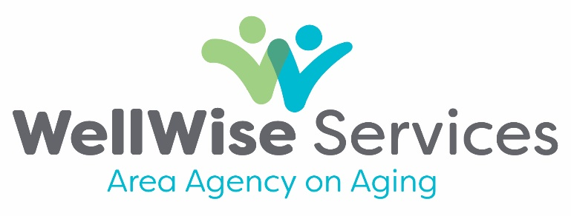
P.O. Box 189
107 Chicago Street
Brooklyn, Michigan 49230

NOTICE OF OPEN MEETINGS

Contact: Greg Schira, Executive Assistant
(517) 592-1924

WellWise Services Area Agency on Aging will hold the following meetings:

Finance Committee on February 18, 2025 at 1:00 p.m., meeting ID: 894 9563 1211
passcode: 231895, https://us02web.zoom.us/j/89495631211

Personnel Committee on February 18, 2025 at 2:00 p.m., meeting ID: 878 8911 9632
passcode: 480151, https://us02web.zoom.us/j/87889119632

Board of Directors on February 20, 2025 at 2:00 p.m., meeting ID: 863 5935 3758
passcode: 652425, https://us02web.zoom.us/j/86359353758

All meetings are open to the public, and will take place at 107 Chicago Street, Brooklyn, Michigan, as well as virtually. Call (312) 626-6799, and enter the respective meeting ID and passcode to join a meeting virtually with audio only. Please contact WellWise Services Area Agency on Aging at (517) 592-1974 or www.wellwiseservices.org for additional information.

