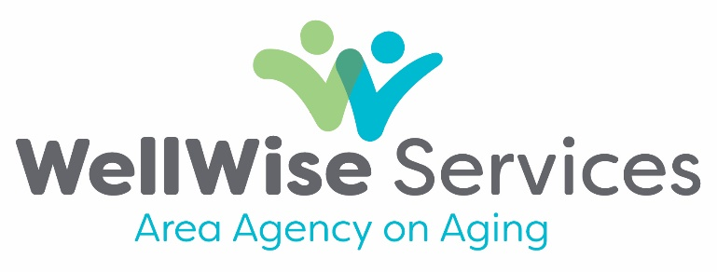
P.O. Box 189
107 Chicago Street
Brooklyn, Michigan 49230

NOTICE OF OPEN MEETINGS, JUNE 2025

Contact: Greg Schira, Executive Assistant
(517) 592-1924

WellWise Services Area Agency on Aging will hold the following meetings:

Personnel Committee on June 16, 2025 at 2:00 p.m., meeting ID: 878 8911 9632
passcode: 480151, https://us02web.zoom.us/j/87889119632

Advisory Council on June 17, 2025 at 10:00 a.m., meeting ID: 860 1815 7499
passcode: 934262, https://us02web.zoom.us/j/86018157499

Finance Committee on June 17, 2025 at 2:00 p.m., meeting ID: 894 9563 1211
passcode: 231895, https://us02web.zoom.us/j/89495631211

Compliance Committee on June 19, 2025 at 12:30 p.m., meeting ID: 891 5502 1887
passcode: 555680, https://us02web.zoom.us/j/89155021887

Board of Directors on June 19, 2025 at 2:00 p.m., meeting ID: 863 5935 3758
passcode: 652425, https://us02web.zoom.us/j/86359353758

All meetings are open to the public, and will take place at 107 Chicago Street, Brooklyn, Michigan, as well as virtually. Call (312) 626-6799, and enter the respective meeting ID and passcode to join a meeting virtually with audio only. Please contact WellWise Services Area Agency on Aging at (517) 592-1974 or www.wellwiseservices.org for additional information.

